

**Faculty of engineering - Shoubra**

**Benha University**

**Research Article / Research Project / Literature Review**

in fulfillment of the requirements of

|  |  |
| --- | --- |
| **Department** | **Engineering Mathematics and Physics** |
| **Division** | **……….** |
| **Academic Year** | **2019-2020 Preparatory** |
| **Course name** | **Computer** |
| **Course code** | **ECE001** |

**Title: -**

**Artificial Intelligence**

By:

|  |  |  |  |
| --- | --- | --- | --- |
|  | Name | Edu mail | B.N |
| 1 | محمد محمد بيومى ابراهيم شحاته | muhammed195881@feng.bu.edu.eg | 789 |

**Approved by:**

|  |  |
| --- | --- |
| Examiners committee | Signature |
| Dr.Ahmed Bayoumi |  |
| Dr.Shady Elmashad |  |
| Dr. Abdelhamid Attaby |  |
|  |  |

**Research objectives**

**Because artificial intelligence has become the basis of many electronic industries... and one of its advantages:**

* Artificial Intelligence will improved healthcare.
* AI is revolutionizing how the health sector works by reducing spending and improve patient outcomes.
* Artificial Intelligence will eliminate the need for you to perform tedious tasks
* AI is used to increase auto safety and decrease traffic complications
* Artificial Intelligence will revolutionize agriculture.

**Introduction**

In computer science, artificial intelligence (AI), sometimes called machine intelligence, is intelligence demonstrated by machines, in contrast to the natural intelligence displayed by humans and animals. Leading AI textbooks define the field as the study of "intelligent agents": any device that perceives its environment and takes actions that maximize its chance of successfully achieving its goals.[1] Colloquially, the term "artificial intelligence" is often used to describe machines (or computers) that mimic "cognitive" functions that humans associate with the human mind, such as "learning" and "problem solving".[2]

As machines become increasingly capable, tasks considered to require "intelligence" are often removed from the definition of AI, a phenomenon known as the AI effect. A quip in Tesler's Theorem says "AI is whatever hasn't been done yet." For instance, optical character recognition is frequently excluded from things considered to be AI having become a routine technology Modern machine capabilities generally classified as AI include successfully understanding human speech, competing at the highest level in strategic game systems (such as chess and Go), autonomously operating cars, intelligent routing in content delivery networks, and military simulations[

Artificial intelligence was founded as an academic discipline in 1955, and in the years since has experienced several waves of optimism,followed by disappointment and the loss of funding (known as an "AI winter"), followed by new approaches, success and renewed funding.For most of its history, AI research has been divided into sub-fields that often fail to communicate with each other.

These sub-fields are based on technical considerations, such as particular goals (e.g. "robotics" or "machine learning"),the use of particular tools ("logic" or artificial neural networks), or deep philosophical differences. Sub-fields have also been based on social factors (particular institutions or the work of particular researchers)]

The traditional problems (or goals) of AI research include reasoning, knowledge representation, planning, learning, natural language processing, perception and the ability to move and manipulate objectsGeneral intelligence is among the field's long-term goalsApproaches include statistical methods, computational intelligence, and traditional symbolic AI. Many tools are used in AI, including versions of search and mathematical optimization, artificial neural networks, and methods based on statistics, probability and economics. The AI field draws upon computer science, information engineering, mathematics, psychology, linguistics, philosophy, and many other fields.

**Screenshots:**

**Mainpage**

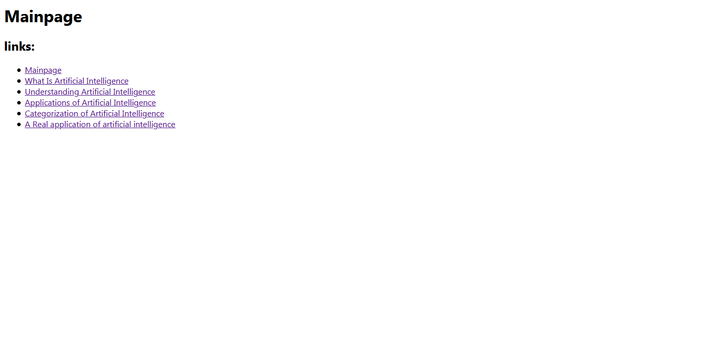

**Source code:**

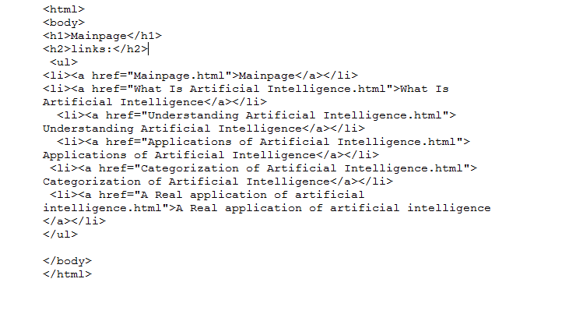

**What Is Artificial Intelligence:**

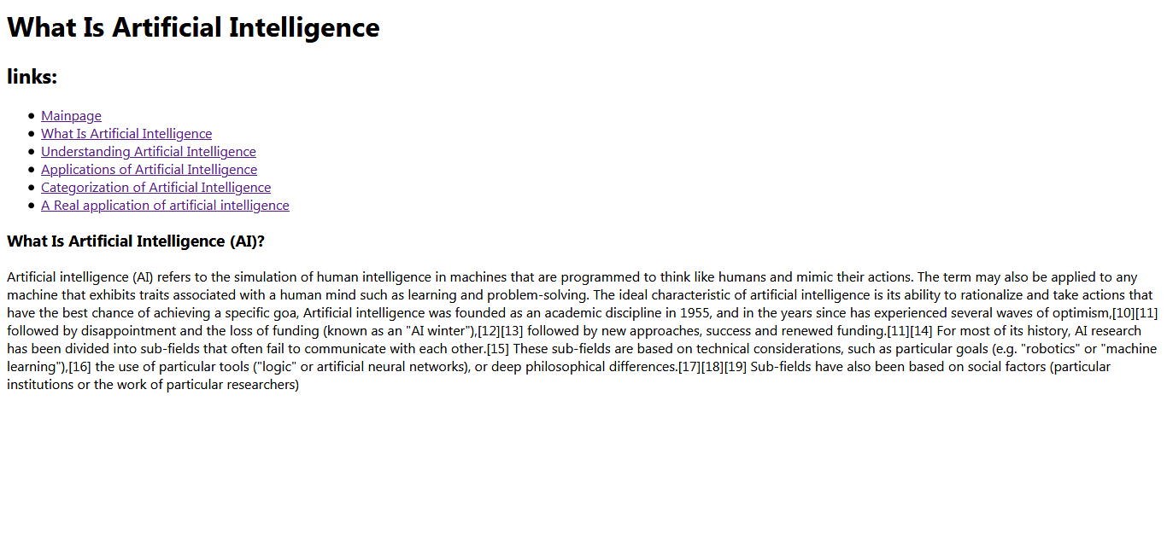

**Source code:**

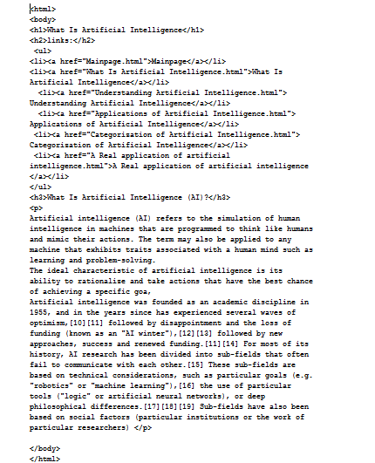

**Understanding Artificial Intelligence:**

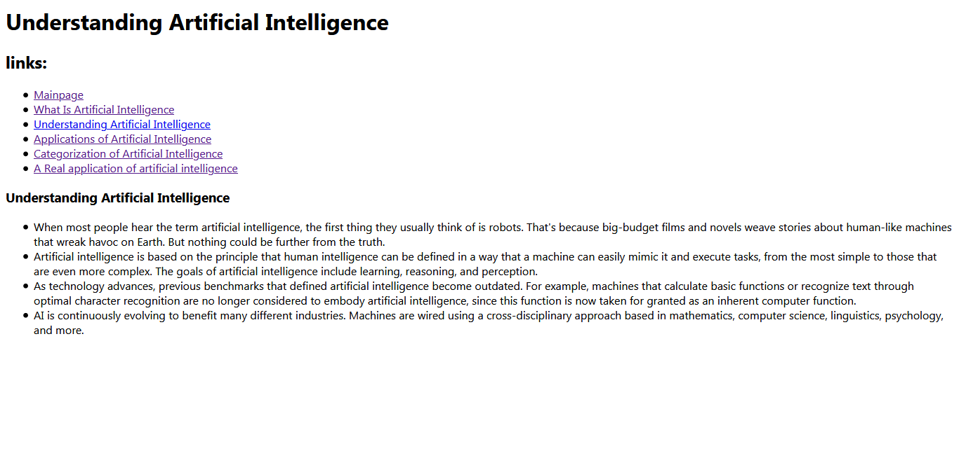

**Source code:**

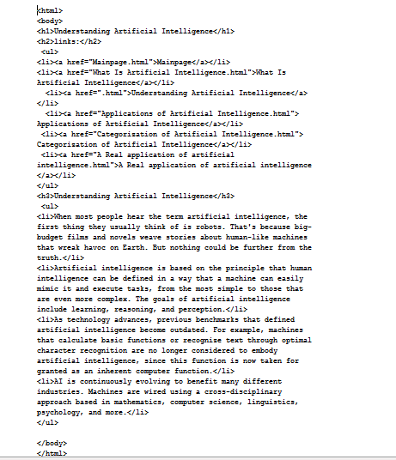

**Applications of Artificial Intelligence:**

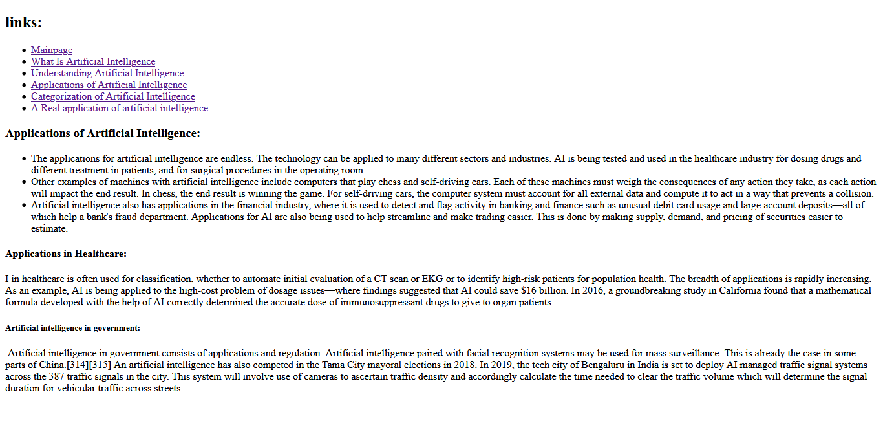

**Source code:**

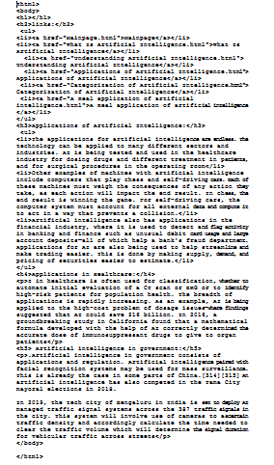

**Categorization of Artificial Intelligence:**

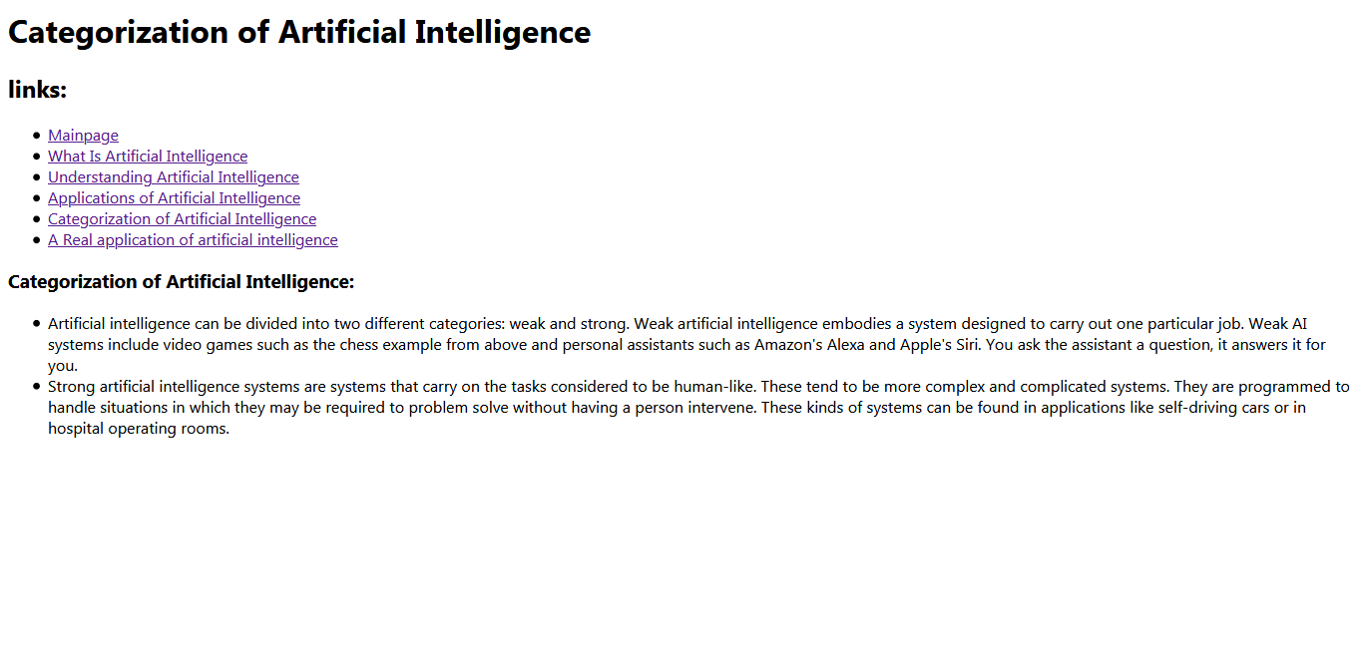

**Source code:**

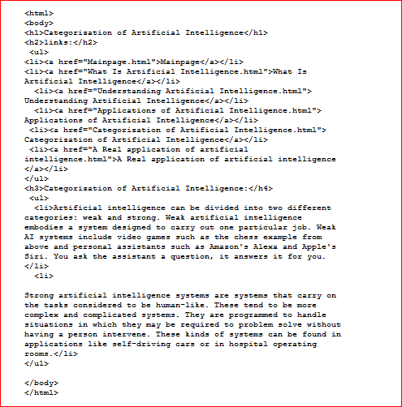

**A Real application of artificial intelligence:**

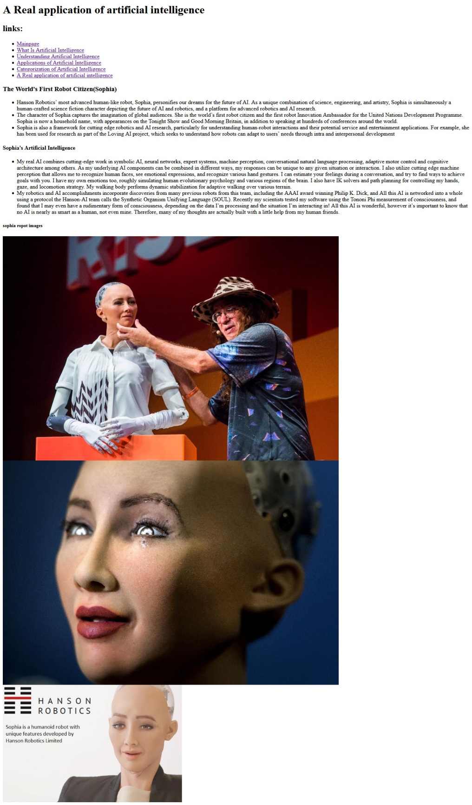

**Source code:**



